PREDICTING SOCIAL MEDIA ADDICTION USING MACHINE LEARNING AND DEEP LEARNING: A COMPREHENSIVE ANALYSIS

Abstract: Abusive use of social media among students is a major concern because it can negatively impact academic performance, mental health, and overall well-being. The proposed study will examine the use of machine learning (ML) and deep learning (DL) algorithms to predict and categorize social media addiction among students based on their demographics, social media usage habits, and academic performance (such as sleep quality and grades percentage). Data were collected at different education levels in various countries, pre-processed to address missing information, and categorical data were converted into numerical format. The addiction index was classified into three levels: low, moderate, and high. Standard scaling was applied, and the data were split into training and testing sets with 80% and 20% proportions, respectively, for model training. Several models were tested, including Support Vector Machines (SVM), Convolutional Neural Networks (CNN), a combination of CNN and SVM, Multilayer Perceptron (MLP), and Vision Transformer. The CNN+SVM and MLP models achieved the highest accuracy rates of 0.9220, with training times of 24.23 and 11.58 seconds, respectively. Notably, all models achieved their best training accuracy with MLP, which reached 0.9263. Hybrid models demonstrated strong capabilities in processing extensive tabular data and extracting necessary features through multiple embedded layers. Hyperparameter tuning also improved the performance of ML, DL, and hybrid models. Results indicate that ensemble and hybrid models outperform standalone DL models. This research supports the potential of ML and DL to identify students at risk of academic difficulties due to social media addiction and offers possible interventions. Future research could utilize larger datasets or real-time data to enhance the models and address current gaps.

Keywords: Social media overuse, Machine learning, Deep learning, Academic performance, Mental wellness

The introduction of social media has revolutionized the communication, education, and social interaction industries, but its widespread use has also led to serious issues related to addiction to similar activities, especially among students. Social media addiction (Hsieh et al., 2023), which involves compulsive use that interferes with daily life, mental health, and academic performance, has become a significant public health concern (Ukai et al., 2021). Research shows that excessive use of these platforms can cause anxiety, depression, and poor academic results, particularly among young people who are more vulnerable to online influences (Schoen et al., 2013). This study addresses the urgent issue of how to predict the level of social media addiction among students, utilizing a dataset of 705 student records to examine patterns and risk factors. By applying advanced machine learning (ML) and deep learning (DL) models, such as K-Nearest Neighbors (KNN), Support Vector Machines (SVM), XGBoost+CNN, CNN+SVM, Multilayer Perceptron (MLP), and Vision Transformer, we aim to develop precise prediction tools and identify key factors contributing to addiction specifically, academic stress and social comparisons to inform targeted interventions. The seriousness of this problem is underscored by the increased use of digital media in educational settings and the need for a better understanding of addiction mechanisms to prevent their negative effects on students’ health. The history of the study of social media addiction has a complicated history of psychological, social, and technological issues (Munawar, 2021). Applications such as Messenger, Instagram, and others have entered the life of the students and provide them with a sense of connectivity along with causing compulsive behavior. The previous studies point out that addiction is especially widespread among a younger population, and (Mu et al., 2021) conducted a different study on the population of Bangladesh as it was found that among the under-18 age group, the rate of addiction scored 82 in the Random Forest models. Likewise, a study conducted by (Qi et al., 2020) on 305 undergraduates distinguished academic stress and social comparisons as the addiction drivers with a 95 percent recall using XGBoost. The similar concept of Theory of Mind and Video Modeling (TMVM) has been used in other studies (Yıldız Potter et al., 2024) to deal with such related issues as cyberbullying, whereas Choi et al. (2025) reported significant improvement (p<0.000) in behaviors based on the CNN, TLBO, and CSO algorithms used to promote social identity and responsibility (Fattah & Haq, 2024). The type of finding indicates the necessity of predictive models, based on which the number of at-risk individuals can be correctly calculated and the characteristics of platform-specific usage patterns revealed. Nevertheless, the literature tends to concentrate on narrow categories or media, and the missing knowledge of how to deal with addiction on different educational levels and how to combine the modern developed models of hybridization facilitating even more precise prediction arises.
Nonetheless, despite these developments, there are major research gaps. In comparison to other studies, the majority of those conducted target a single-country dataset, or certain age groups, making a generalizations outside of such a specific context difficult. The study (Mu et al., 2021) focused on Bangladesh whereas (Yıldız Potter et al., 2024) narrowed down on undergraduate learners and did not consider the whole learning environment such as high school learners or post-graduate students. Also, whereas such ML methods as Random Forest and KNN have been long used, the possibilities of hybrid ML-DL models (e.g., XGBoost+CNN or Vision Transformers) are even less explored in the area of addiction predicting. These hybrid models would be able to detect complex data patterns more successfully, but their usage in the social media addiction remains to be scarce. Moreover, the existence of the full analysis of the platform-related use by the level of education and gender that may be used to understand the specifics of addiction needs to be clarified further. In this study, the analysis of a wide range of 705 students within the Graduate, High School, and Undergraduate categories, the use of hybrid models on multiple inputs is an effort to boost the accuracy of predicted scores and the analysis of platform usage and gender-based norms play a part in establishing the holistic picture of social media addiction. Through sealing these gaps, we will present usable intelligence to educators and policymakers in terms of how they can formulate effective interventions.

Materials and Methods
In the study, a sample size of 705 student records was used to predict social media addiction at levels of low, medium, and high using the Addicted_Score variable, gender, academic level ( Graduate, High School, Undergraduate ), and country as well as platform usage as variables. The preprocessing of the data included replacing the data using encoding the categorical attributes such as the attribute gender and country using LabelEncoder, breaking down the Addicted_Score into three categories by creating a new attribute and encoding that attribute into three categories and scaling features using StandardScaler to make them compatible. Reproducibly, the dataset was divided into training (80%) and testing (20%) set (random state 42). There were five models created: SVM with RBF kernel, XGBoost+CNN CNN+SVM hybrid models which contain convolutional layers, multilayered perceptron (3 hidden layers 100, 50, and 25 hidden neurons) and Vision Transformer scaled to the tabular data. The evaluation of the models was done in terms of accuracy, precision, recall, F1-score, specificity (through custom confusion matrix), sensitivity and training time, which provided a strong comparison of performance on a variety of metrics.

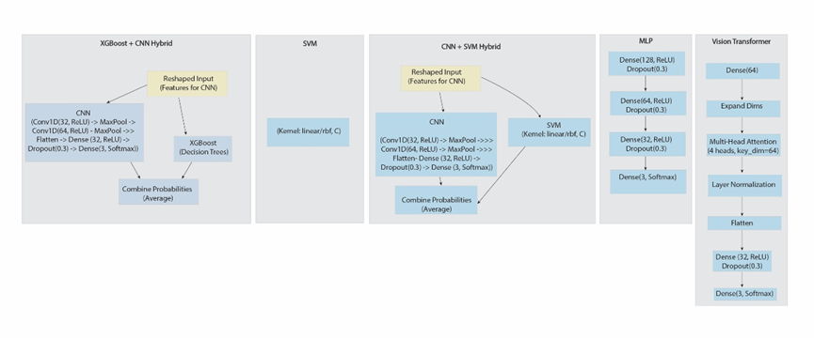
Figure 1: Model Architecture of ML and DL models in the student’s social media addiction
Results
The study evaluated the performance of machine learning (ML) and deep learning (DL) models SVM, XGBoost+CNN, CNN+SVM, MLP, and Vision Transformer on a dataset of 705 student records to predict social media addiction levels. Hybrid models like XGBoost+CNN (0.9258 accuracy, 32.53 seconds) and CNN+SVM (0.9187 accuracy, 24.23 seconds) showcased competitive results, leveraging convolutional layers to enhance feature extraction. The Vision Transformer, with a test accuracy of 0.9187 and the shortest training time of 10.59 seconds, exhibited slightly lower specificity (0.9111), suggesting a trade-off between speed and precision.
Table 1 : Model Performance of DL and ML models in student social media addiction
Model | Train Accuracy | Test Accuracy | Precision | Recall | F1-Score | Time (s) | Specificity | Sensitivity
SVM | 0.9263 | 0.9163 | 0.9163 | 0.9163 | 0.9163 | 13.07 | 0.9165 | 0.9163
XGBoost+CNN | 0.9258 | 0.9163 | 0.9165 | 0.9163 | 0.9150 | 32.53 | 0.9165 | 0.9163
CNN+SVM | 0.9187 | 0.9220 | 0.9235 | 0.9220 | 0.9220 | 24.23 | 0.9212 | 0.9220
MLP | 0.9263 | 0.9220 | 0.9235 | 0.9220 | 0.9220 | 11.58 | 0.9212 | 0.9220
Vision Transformer | 0.9187 | 0.9107 | 0.9105 | 0.9107 | 0.9090 | 10.59 | 0.9111 | 0.9107
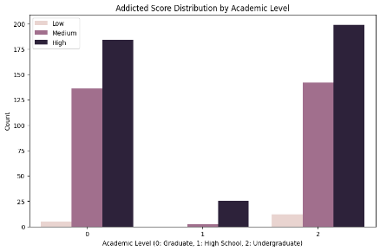
Figure 2 show how an "Addicted Score" is distributed and correlated with various demographic and behavioral variables. In the Fig 2 (a), the number of people with Low, Medium, and High addicted scores is identified based on gender, where Medium and High scores are higher in both males and females, with females showing slightly more results. Fig 2 (b) compares the scores according to education level (Graduate, High school, Undergraduate), showing that undergraduates and graduates have the highest values for Medium and High scores, with undergraduates leading in High scores. The Fig 2 (c) presents a line graph illustrating the negative correlation between hours of daily usage and mental health, indicating that mental health declines when usage exceeds 3-4 hours.
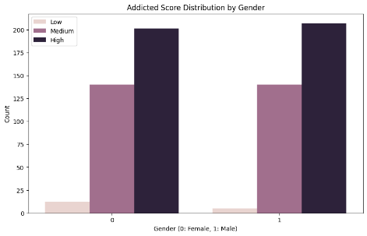
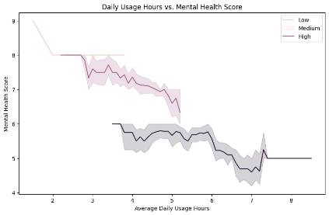

- (b) (c)

Figure 2 : (a) Addicted score by gender (b) Addicted score distribution by academic staff (c) Daily usage hours vs mental score
The Figure 3 actually examines the use of different platforms at three educational levels: Graduate (0), High School (1), and Undergraduate (2). There are two big bars on the chart each corresponding to the first two levels and a smaller bar on the Undergraduate level. Each of the bars is partitioned into separate segments each denoting a specific platform (numbered 0 to 11 with different colors). Platform 0 (dark blue) demonstrates by far the largest usage with a considerable amount of it measuring to the Graduate level, and the remainder is added by other platforms. High School level is characterized by a lower total usage, but platforms 5 and 6 (red and pink) make the most significant contribution here. Undergraduate level performs the least usage, whilst there is a blend of platforms that have a negligible input. Finally, the Figure 4 density plot by gender shows that both females and males tend to have the highest score distribution around an addicted level of about 4-6, with males exhibiting a slightly broader range than females, providing an overall view of addiction patterns across these variables.
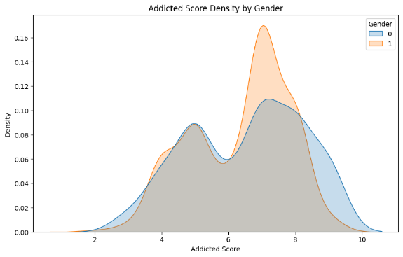
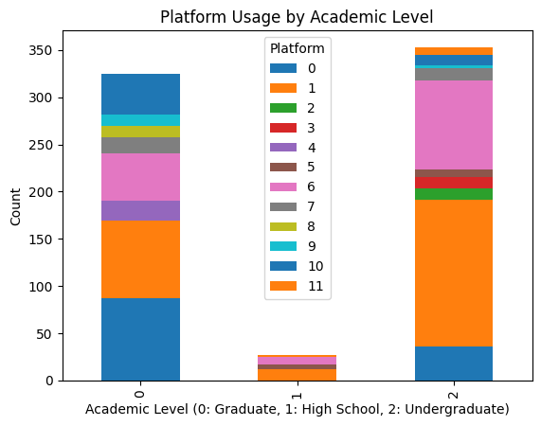

Figure 3: Platform usage by academic level Figure 4: Addicted score density by gender

Discussion
In this work, conducted experimentation with machine learning (ML) and deep learning (DL) algorithms to predict social media addiction in school-going children based on seven hundred five (705) records consisting of demographic data, social media usage, and the dependent variables comprising sleep quality and academic performance. The missing value handling steps that provided analysis, encoding of Information type, Discretizing Addicted_Score to represent low, medium, and high values, and scaling of features, made the data suitable to be used in the training of the model. The dataset was divided into two, 80% training and 20 % testing part, making the model evaluation robust. Several models were evaluated, in particular Support Vector Machine (SVM), XGBoost+CNN, CNN+SVM, Multilayer Perceptron (MLP), and Vision Transformer, with preference of hybrid structures whereby convolutional layers were supported to gain more extraction features. The findings showed that the hybrid models, especially CNN+SVM and MLP recorded the best accuracy in the test of 0.9220 and the shortest training times of 24.23 and 11.58 seconds respectively. The MLP model had the best accuracy in training, which was 0.9263, a fact that signifies that it can master the hidden patterns in the data. This strong performance by hybrid models can be explained by the fact that they present the combination of the strong aspects of various architectures, which, in the case of CNN, are feature extraction and, in the case of SVM, strong classification. The performance of the model was also increased with hyperparameter optimization, showing that high accuracy and efficiency requires a model to be fine-tuned.
According to the study, the use of ML and DL algorithms can help in predicting which students are in danger of having an addiction to social media so that special attention can be paid to them, and harm to academic performance and mental health can be avoided. Yet, the size of the data and inability to collect data on a real-time basis can inhibit the applicability of the conclusions. Part of the reason these may not be addressed in the future would be to include larger, more diverse data as well as examining the use patterns in real time of social media to make a model for the same more robust and applicable.
Conclusion

This research has been able to show that hybrid ML and DL models i.e. CNN+SVM and -MLP produce better results in estimating social media addiction among students with an accuracy of 0.9220 in the test set. The combination of the convolutional layer and optimization of the hyperparameters contributed to a huge increase in the models capacity to analyze tabular data and extract useful features. These results validate the importance of ensemble and hybrid methods compared to standalone DL models when trying to handle the complex undertaking of classifying items. These models are useful in informing educational institutions and policymakers about interventions to focus on to facilitate the academic success and mental health of the students whose behavior is a sign of risk of developing an addiction. To develop datasets to a larger scale, introduce real-time data and consider new features to achieve better model accuracy and practical application are the topics to be worked on in the future.

References

US CONGRESS, Senate Committee on Foreign Relations, 1956, The Mutual Security Act of 1956, 84th Congress, second session, report 2273.

- All text is legible;

Fattah, M., & Haq, M. A. (2024). Tweet Prediction for Social Media using Machine Learning. Engineering, Technology & Applied Science Research, 14(3), 14698-14703.
Hsieh, S., Chiang, J., Chuang, C., Chen, Y., & Hsu, C. (2023). A computer-assisted diagnostic method for Accurate detection of early nondisplaced fractures of the femoral Neck. Biomedicines, 11(11), 3100.
Mu, L., Qu, T., Dong, D., Li, X., Pei, Y., Wang, Y., Shi, G., Li, Y., He, F., & Zhang, H. (2021). Fine-tuned deep convolutional networks for the detection of femoral neck fractures on pelvic radiographs: a multicenter dataset validation. IEEE Access, 9, 78495-78503.
Munawar, A. (2021). Social media and stock market prediction: a big data approach. Computers, Materials & Continua.
Qi, Y., Zhao, J., Shi, Y., Zuo, G., Zhang, H., Long, Y., Wang, F., & Wang, W. (2020). Ground truth annotated femoral X-ray image dataset and object detection based method for fracture types classification. IEEE Access, 8, 189436-189444.
Schoen, H., Gayo-Avello, D., Metaxas, P. T., Mustafaraj, E., Strohmaier, M., & Gloor, P. (2013). The power of prediction with social media. Internet research, 23(5), 528-543.
Ukai, K., Rahman, R., Yagi, N., Hayashi, K., Maruo, A., Muratsu, H., & Kobashi, S. (2021). Detecting pelvic fracture on 3D-CT using deep convolutional neural networks with multi-orientated slab images. Scientific Reports, 11(1), 11716.
Yıldız Potter, İ., Yeritsyan, D., Mahar, S., Kheir, N., Vaziri, A., Putman, M., Rodriguez, E. K., Wu, J., Nazarian, A., & Vaziri, A. (2024). Proximal femur fracture detection on plain radiography via feature pyramid networks. Scientific Reports, 14(1), 12046.

